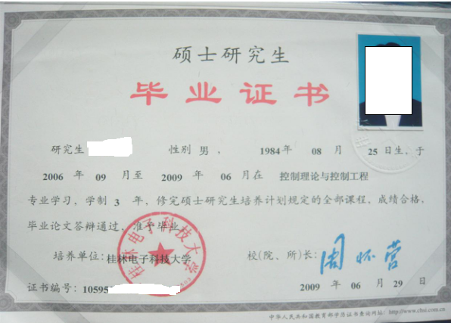
CERTIFICATE FOR GRADUATION

GUILIN UNIVERSITY OF ELECTRONIC TECHNOLOGY

Certificate No: 10595*************
This is to certify that ZHANG SAN, male, born in August 25,1984, majoring in Control Theory and Control Engineering in the School of Computer and Control Engineering of this university from September 2006 to June 2009, has successfully fulfilled all curriculums of the three-year graduate program of study, and passed the examinations. Hereby he is allowed to graduate.

President: ZHOU HUAI YING
Guilin University of Electronic Technology
June 29, 2009

